. “ MATRIX CALCULATOR ”

A Project Report submitted
In partial fulfillment of the requirements for the award of the degree of
BACHELOR OF TECHNOLOGY IN
COMPUTER SCIENCE & ENGINEERING (DATA SCIENCE)

Submitted by
UMMIDI VENKATA RAMANA
Regd No. 2025191796

Under the esteemed guidance of

Dr. Devarapalli Ravi Kishore, Associate Professor, CSE DS



DEPARTMENT OF COMPUTER SCIENCE AND ENGINEERING (DATA SCIENCE)

GITAM SCHOOL OF TECHNOLOGY
GITAM (Deemed to be University)
VISAKHAPATNAM
2025

DEPAR.
TMENT OF COMPUTER SCIENCE AND ENGINEERING (DATA SCIENCE)

GITAM SCHOOL OF TECHNOLOGY
GITAM (Deemed to be University)



DECLARATION

I hereby declare that the project report entitled “MATRIX CALCULATOR” is an original work done in the Department of Computer Science and Engineering (Data Science), GITAM School of Technology, GITAM (Deemed to be University) submitted in partial fulfillment of the requirements for the award of the degree of B.Tech. in Computer Science and Engineering. The work has not been submitted to any other college or University for the award of any degree or diploma.

Date:

Registration No Name Student Signature
2025191796 UMMIDI VENKATA RAMANA
DEPAR.
TMENT OF COMPUTER SCIENCE AND ENGINEERING (DATA SCIENCE)
GITAM SCHOOL OF TECHNOLOGY
GITAM (Deemed to be University)



CERTIFICATE

This is to certify that the project report entitled “MATRIX CALCULATOR” is a bonafide record of work carried out by UMMIDI VENKATA RAMANA, Regd No 2025191796, submitted in partial fulfillment of requirement for the award of degree of Bachelors of Technology in Computer Science and Engineering (Data Science).

Date :

Project Guide
Dr. Devarapalli Ravi Kishore Associate Professor

. TABLE OF CONTENTS

S.No | Description | Page No.
1. | Introduction 5
2. | Aim of the Project 5
3. | Problem Definition & Objectives 6
4. | Code For The Matrix Multiplier 9
5. | Outputs 14
6. | Future Work 18
7. | Conclusion 19

INTRODUCTION

In the field of mathematics and computational science, matrices form the backbone of numerous analytical and problem-solving techniques. From solving systems of linear equations to applications in computer graphics, machine learning, electrical circuits, and physics simulations, matrices are indispensable. However, performing matrix operations manually—especially for higher-order matrices—can be complex, time-consuming, and highly prone to human error. This creates a need for efficient computational tools that can automate these processes while maintaining accuracy and speed.
The Matrix Calculator is a software application developed using the Python programming language with the objective of simplifying and automating matrix operations. Python, being a versatile and powerful language, offers extensive support for numerical computations through libraries such as NumPy, which significantly enhances the efficiency of matrix calculations. By leveraging such tools, the project bridges the gap between theoretical mathematical concepts and practical computational implementation.
This project adopts a modular and menu-driven approach, allowing users to interact with the system in a structured and intuitive manner. The application enables users to input matrices of varying dimensions and perform operations such as addition, subtraction, multiplication, determinant evaluation, and eigenvalue and eigenvector computation. Each functionality is implemented as a separate module, ensuring clarity, reusability, and ease of debugging.
In addition to simplifying calculations, the Matrix Calculator serves as an educational tool that helps users better understand the underlying principles of matrix algebra. By providing immediate results and allowing experimentation with different inputs, the system enhances conceptual learning and promotes a deeper appreciation of linear algebra.
Overall, this project exemplifies how programming can be effectively utilized to solve mathematical problems, improve computational efficiency, and provide user-friendly solutions for complex analytical tasks.

AIM OF THE PROJECT

The primary aim of the Matrix Calculator project is to design and implement a robust, efficient, and user-friendly software application capable of performing a wide range of matrix operations. The project seeks to provide a computational platform that reduces the complexity involved in manual matrix calculations while ensuring accuracy and reliability.
The specific aims of the project are as follows:
- To develop a menu-driven Python program that allows users to perform fundamental matrix operations such as addition, subtraction, and multiplication.
- To implement determinant calculation for square matrices, enabling users to analyze matrix properties effectively.
- To incorporate advanced mathematical computations such as the calculation of eigenvalues and eigenvectors, which are essential in various engineering and scientific applications.
- To utilize the capabilities of numerical libraries such as NumPy to enhance computational speed and efficiency.
- To design the system in a modular manner, ensuring that each operation is implemented as an independent function for better readability, maintainability, and scalability.
- To provide a simple and interactive user interface that allows users to input matrices and select operations without difficulty.
- To minimize human errors associated with manual calculations by automating all computational processes.
- To create a learning tool that helps students and users understand matrix operations through practical implementation.
Through these objectives, the project aims to demonstrate the practical application of programming in solving mathematical problems and to highlight the importance of computational tools in modern scientific and engineering practices.

PROBLEM DEFINITION AND OBJECTIVES

PROBLEM DEFINITION

Matrix operations are a fundamental part of many academic and real-world applications, particularly in fields such as engineering, computer science, physics, and data analysis. Despite their importance, performing these operations manually can be tedious and error-prone, especially when dealing with large matrices or complex computations such as determinants and eigenvalues.
Students and professionals often face difficulties in accurately solving matrix-related problems due to the extensive calculations involved. Traditional methods require significant time and effort, and even a small computational mistake can lead to incorrect results. Moreover, there is often a lack of simple, accessible tools that allow users to perform these operations efficiently without requiring advanced software knowledge.
Therefore, there is a clear need for a lightweight, user-friendly application that can handle matrix operations efficiently while providing accurate results. Such a tool should allow users to input matrices, perform various operations, and obtain results instantly, thereby reducing manual effort and improving productivity.

OBJECTIVES

MAIN OBJECTIVES:

• To develop a functional Python-based application capable of performing essential matrix operations including addition, subtraction, multiplication, determinant calculation, and eigenvalue/eigenvector computation.
• To provide an efficient computational system that reduces the time and effort required for manual matrix calculations.
• To ensure accuracy and reliability in all operations by utilizing robust algorithms and numerical libraries.

• To create an interactive and user-friendly interface that simplifies user interaction with the system.

TECHNICAL OBJECTIVES:

• To implement matrix operations using appropriate data structures such as lists and NumPy arrays.
• To utilize modular programming techniques by dividing the program into well-defined functions for each operation.
• To integrate the NumPy library for efficient computation of advanced mathematical operations such as eigenvalues and eigenvectors.
• To perform input validation to ensure that matrix dimensions are compatible for the selected operations.
• To handle errors gracefully and provide meaningful feedback to the user in case of invalid inputs.
• To design the program in a way that allows future enhancements such as graphical user interfaces or additional matrix operations.
• To ensure that the code is structured, readable, and maintainable for long-term usability and scalability.

CODE

# ==============================
# MATRIX CALCULATOR PROGRAM
# ==============================

# Importing required library for advanced mathematical operations
import numpy as np

# ==============================
# Utility Function: Input Matrix
# ==============================

def input_matrix(rows, cols):
"""
This function takes input from the user for a matrix
of given dimensions (rows x columns).
"""
print(f"Enter elements for a {rows}x{cols} matrix:")
matrix = []

for i in range(rows):
# Taking row input and converting it into float values
row = list(map(float, input(f"Row {i+1}: ").split()))
matrix.append(row)

return matrix

# ==============================
# Utility Function: Print Matrix
# ==============================

def print_matrix(matrix):
"""
This function prints the matrix in a readable format.
"""
for row in matrix:
print(row)

# ==============================
# 1. Matrix Addition
# ==============================

def add_matrices(A, B):
"""
This function performs element-wise addition of two matrices.
Both matrices must have the same dimensions.
"""
result = []

for i in range(len(A)):
row = []
for j in range(len(A[0])):
row.append(A[i][j] + B[i][j])
result.append(row)

return result

# ==============================
# 2. Matrix Subtraction
# ==============================

def subtract_matrices(A, B):
"""
This function performs element-wise subtraction of two matrices.
Both matrices must have the same dimensions.
"""
result = []

for i in range(len(A)):
row = []
for j in range(len(A[0])):
row.append(A[i][j] - B[i][j])
result.append(row)

return result

# ==============================
# 3. Matrix Multiplication
# ==============================

def multiply_matrices(A, B):
"""
This function multiplies two matrices using the standard
row-by-column multiplication method.
Number of columns of A must equal number of rows of B.
"""
result = []

for i in range(len(A)):
row = []
for j in range(len(B[0])):
sum_val = 0

for k in range(len(B)):
sum_val += A[i][k] * B[k][j]

row.append(sum_val)

result.append(row)

return result

# ==============================
# 4. Determinant Calculation
# ==============================

def determinant(matrix):
"""
This function calculates the determinant of a matrix.
Supports only 2x2 and 3x3 matrices.
"""

n = len(matrix)

# Determinant for 2x2 matrix
if n == 2:
return matrix[0][0]*matrix[1][1] - matrix[0][1]*matrix[1][0]

# Determinant for 3x3 matrix
elif n == 3:
a = matrix
return (
a[0][0]*(a[1][1]*a[2][2] - a[1][2]*a[2][1])
- a[0][1]*(a[1][0]*a[2][2] - a[1][2]*a[2][0])
+ a[0][2]*(a[1][0]*a[2][1] - a[1][1]*a[2][0])
)

else:
return "Determinant not supported for this size"

# ==============================
# 5. Eigenvalues and Eigenvectors
# ==============================

def eigen_values_vectors(matrix):
"""
This function computes the eigenvalues and eigenvectors
of a square matrix using NumPy library.
"""

np_matrix = np.array(matrix)

# NumPy function to compute eigenvalues and eigenvectors
values, vectors = np.linalg.eig(np_matrix)

print("\nEigenvalues:")
print(values)

print("\nEigenvectors:")
print(vectors)

# ==============================
# Main Menu (User Interface)
# ==============================

while True:
print("\n========== MATRIX CALCULATOR ==========")
print("1. Addition")
print("2. Subtraction")
print("3. Multiplication")
print("4. Determinant")
print("5. Eigenvalues & Eigenvectors")
print("6. Exit")

choice = int(input("Enter your choice: "))

# -------- Addition --------
if choice == 1:
r = int(input("Rows: "))
c = int(input("Cols: "))

A = input_matrix(r, c)
B = input_matrix(r, c)

result = add_matrices(A, B)

print("\nResult:")
print_matrix(result)

# -------- Subtraction --------
elif choice == 2:
r = int(input("Rows: "))
c = int(input("Cols: "))

A = input_matrix(r, c)
B = input_matrix(r, c)

result = subtract_matrices(A, B)

print("\nResult:")
print_matrix(result)

# -------- Multiplication --------
elif choice == 3:
r1 = int(input("Rows of A: "))
c1 = int(input("Cols of A: "))
r2 = int(input("Rows of B: "))
c2 = int(input("Cols of B: "))

# Checking compatibility condition
if c1 != r2:
print("Multiplication not possible!")
else:
A = input_matrix(r1, c1)
B = input_matrix(r2, c2)

result = multiply_matrices(A, B)

print("\nResult:")
print_matrix(result)

# -------- Determinant --------
elif choice == 4:
n = int(input("Enter size (2 or 3): "))
A = input_matrix(n, n)

print("\nDeterminant =", determinant(A))

# -------- Eigenvalues & Eigenvectors --------
elif choice == 5:
n = int(input("Enter size of square matrix: "))
A = input_matrix(n, n)

eigen_values_vectors(A)

# -------- Exit --------
elif choice == 6:
print("Exiting Program...")
break

# -------- Invalid Choice --------
else:
print("Invalid choice. Please try again.")

OUTPUTS

Initial Output:
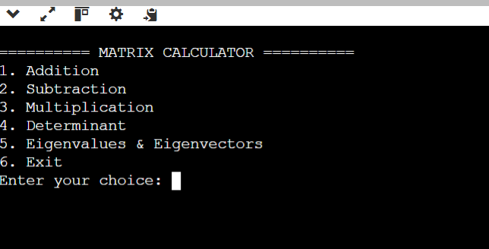

1st Option and Output:
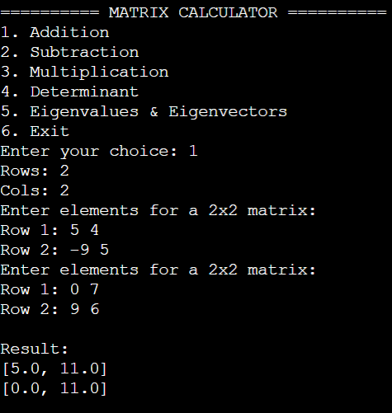

2nd Option and Output:
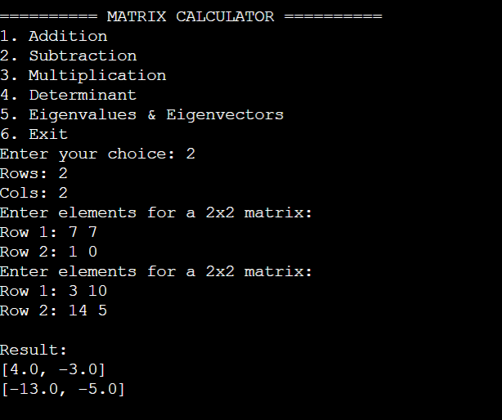

3rd Option and Output:
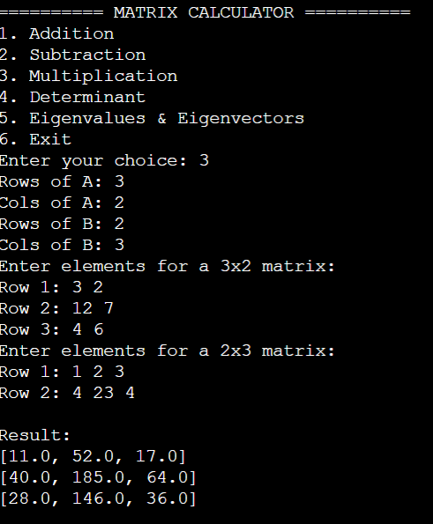

4th Option and Output:
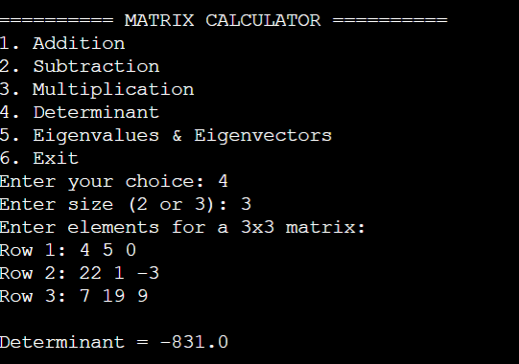

5th Option and Output:
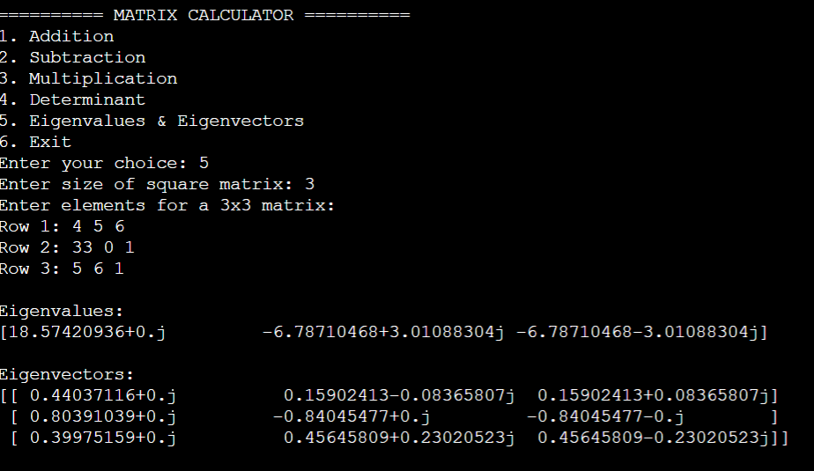

6th Option and Output:
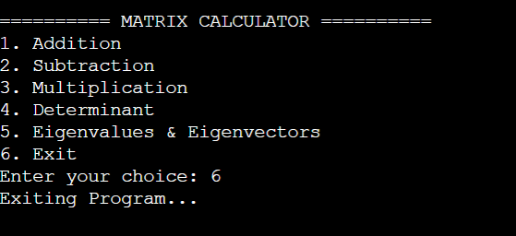

FUTURE WORK

While the current implementation of the Matrix Calculator successfully performs essential matrix operations, there is significant scope for further enhancement and expansion to improve its functionality, usability, and applicability in real-world scenarios.
One of the primary areas of improvement is the extension of determinant calculation and matrix operations to support higher-order matrices beyond 3×3. Implementing recursive algorithms or leveraging advanced numerical methods would allow the system to handle matrices of arbitrary size, thereby increasing its computational capability.
Another important enhancement would be the inclusion of additional matrix operations such as matrix inversion, transpose, rank calculation, and solving systems of linear equations using methods like Gaussian elimination or LU decomposition. These features would make the application more comprehensive and useful for advanced mathematical and engineering applications.
The current system operates through a command-line interface, which, although functional, may not be intuitive for all users. Developing a graphical user interface (GUI) using frameworks such as Tkinter or PyQt would significantly enhance user interaction by providing buttons, input fields, and visual feedback. This would make the application more accessible, especially for users with limited programming knowledge.
Integration with visualization tools could further enhance the project by enabling graphical representation of matrices and transformations. For example, plotting vector transformations or illustrating eigenvector directions could provide deeper insight into linear algebra concepts.
Another potential area of development is the incorporation of error-handling mechanisms and input validation techniques to make the program more robust. Ensuring that invalid inputs are properly handled and meaningful error messages are displayed would improve the overall user experience.
Additionally, the project could be extended into a web-based application using frameworks such as Flask or Django. This would allow users to access the Matrix Calculator through a web browser without the need for local installation, thereby increasing its reach and usability.
Finally, the integration of educational features such as step-by-step solutions for matrix operations could transform the application into a powerful learning tool. This would help students understand not only the results but also the underlying procedures involved in matrix computations.

CONCLUSION

The Matrix Calculator project successfully demonstrates the application of programming techniques to solve mathematical problems efficiently and accurately. By utilizing the capabilities of the Python programming language along with the NumPy library, the project provides a reliable platform for performing fundamental matrix operations.
Throughout the development of this project, several important objectives were achieved. The system effectively automates operations such as matrix addition, subtraction, multiplication, determinant calculation, and eigenvalue and eigenvector computation. This eliminates the need for manual calculations, thereby reducing the likelihood of errors and significantly improving computational speed.
The modular design of the program ensures that each operation is implemented as a separate function, making the code well-structured, easy to understand, and maintainable. The menu-driven interface enhances usability by guiding the user through different functionalities in a systematic manner.
In addition to its practical utility, the project serves as an educational tool that reinforces concepts from linear algebra. By allowing users to experiment with different matrices and instantly observe the results, it bridges the gap between theoretical knowledge and practical application.
Furthermore, the project highlights the importance of computational tools in modern scientific and engineering practices. It demonstrates how programming can be effectively used to simplify complex mathematical operations and provide user-friendly solutions.
In conclusion, the Matrix Calculator is a valuable application that combines mathematical concepts with programming skills to deliver an efficient and practical solution for matrix computations. With further enhancements, it has the potential to evolve into a more advanced and versatile tool for both academic and professional use.

